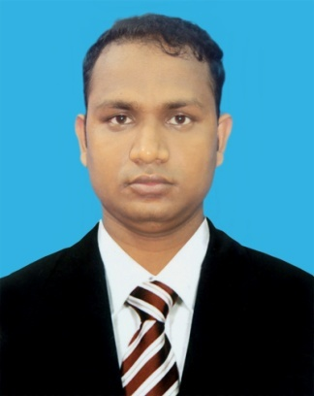

RESUME OF
Md. Abubokkor Siddik

Present Address:

Nikunjo-2, Road-11
House # 30 (4th Floor)
Khilkhet, Dhaka.

Cell : +8801734-681578
E-mail : abubokkor_seu@yahoo.com

Careers Objective:  Known OS & Application Software :  Other Skills :  Undergraduate  Research :  Language Skill : | To be a successful Telecommunication Engineer. Intend to work in a challenging and  Competitive environment where responsibility and commitment is required. I would like to develop  my career in a reputed organization with competitive challenging environment, where outstanding  Performance is to be the success.  - Office 97, 2000, 2007, XP(Microsoft Word, Excel, Access, Power Point)  - Windows 98, 2004, XP  - DOS  - Computer (Hardware) assembling, Troubleshooting & maintenance  - Computer networking solution  - Software installation  - Internet solution  - Adobe Photoshop CS4  Optimize Power Control in CDMA System using channel Prediction.  Excellent listening reading, writing and speaking skill in both Bengali and English.  Clep-Certificate in English Language (Southeast University).
Education :
  Degree | Division | Institute | Year | Acquired number/Grade
  B.Sc. (Eng.) in Electronics & Tele-communication Engineering. | Dhaka. | Southeast University | 2012 | 3.30 out of 4.00
  Higher Secondary Certificate(H.S.C) | Rajshashi. | Jahangirpur Govt. College,Naogaon | 2006 | 3.80 (in a scale  of 5.00)
  Secondary School Certificate(S.S.C) | Rajshashi. | Balu Bazar S.M. High School. | 2004 | 4.13 (in a scale  of 5.00)
Personal Data : | MAJOR FIELD OF STUDY DURING UNDERGRADUATE LEVEL:  - Electrical Circuit design 11)Digital Signal Processing  - Electronics Devices 12)Signals & Systems  - Telecommunication Engineering 13) Electromagnetic Fields & Waves  - Wireless communication 14)Computer Networking  - Mobile communication 15) Optoelectronic Devices  - Optical Fiber Communication 16) Data Communication  - Digital & Satellite communication 17)Programming Language  - Radio & Television 18)Computer Interfacing  - Control System 19)Digital Logic Design  - VLSI Design 20)Numerical Methods  Name : Md. Abubokkor Siddik  Father’s name : Md. Belal Hossain  Mother’s name : Anjuara  Date of birth : 26th Oct., 1987.  Gender : Male.  Nationality : Bangladeshi.  Religion : Islam.  Permanent address : Vill: Bashbaria, P.O: Paharpur,  P.S: Mohadevpur, Dist.: Naogaon.  Current Location : Khilkhet, Dhaka.
Reference
  Md. Asaduzzaman Khan  Lecturer  Dept. of ETE  Southeast University, Dhaka.  Phone : 01716-094556  Md. Maruf Hossain  System Engineering  Airtel NOC  Mobile: +8801615-577892 | Dr. Mohammad Quamruzzaman  Associate professor &  Chairman (Acting)  Dept. of ETE & EEE  Southeast University  Banani, Dhaka-1213  Phone : 01912-012058  Md.Selim Miah  Lead Engineer  CSP/IN,Network Operations,  Technology division,  GrameenPhone Ltd.

With Regards
…………………............
(Md. Abubokkor Siddik)

